Stu 1.ID: 21165073 Name 1: Kwok Tsz Yeung
Stu 2.ID: 21162447 Name 2: He Zhengzhe

Reference Solution
Lab 6: Determine motor position and PID Control
Task 1 – Determine motor position from Hall-effect Rotary Encoder:
The actual counts per revolution is _338_
Screenshot of encoderCount and position when motor move forward (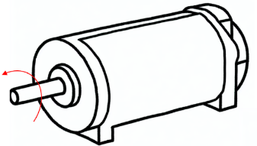):

Screenshot of encoderCount and position when motor move backward (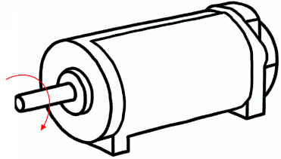):

Task 2 – P controller
Kp=___0.04___
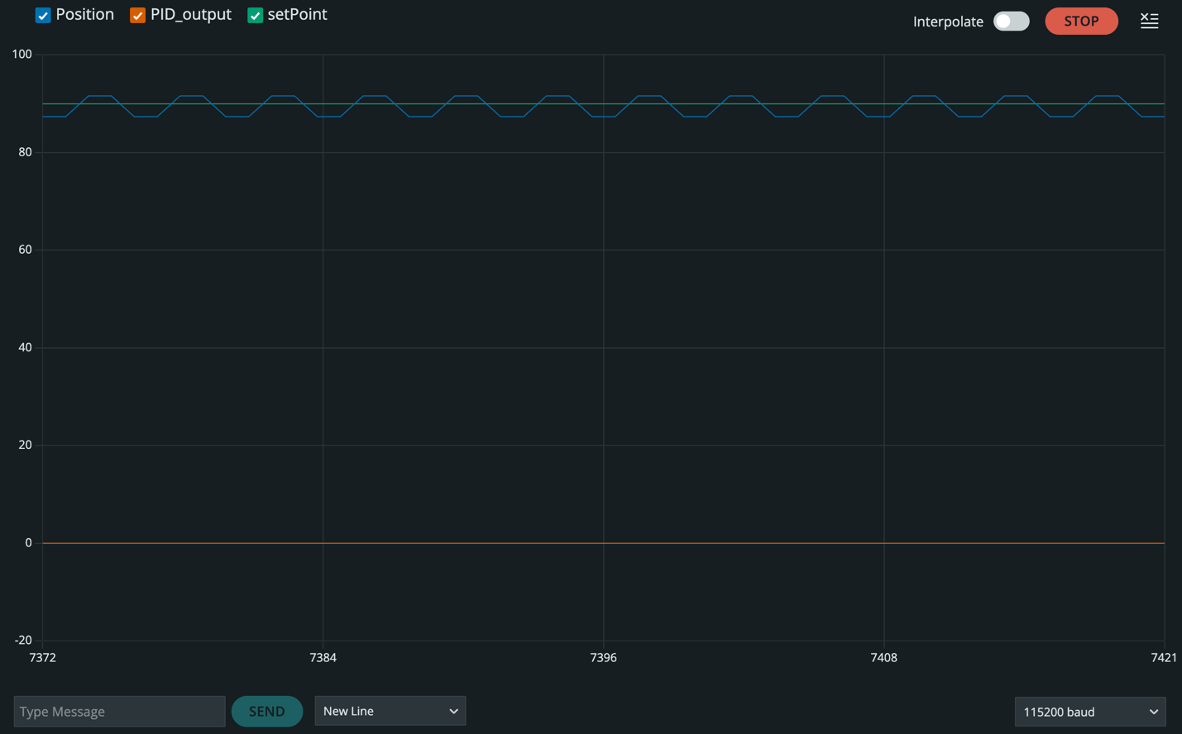

Task 3 – PI controller
Ki=_0.03_
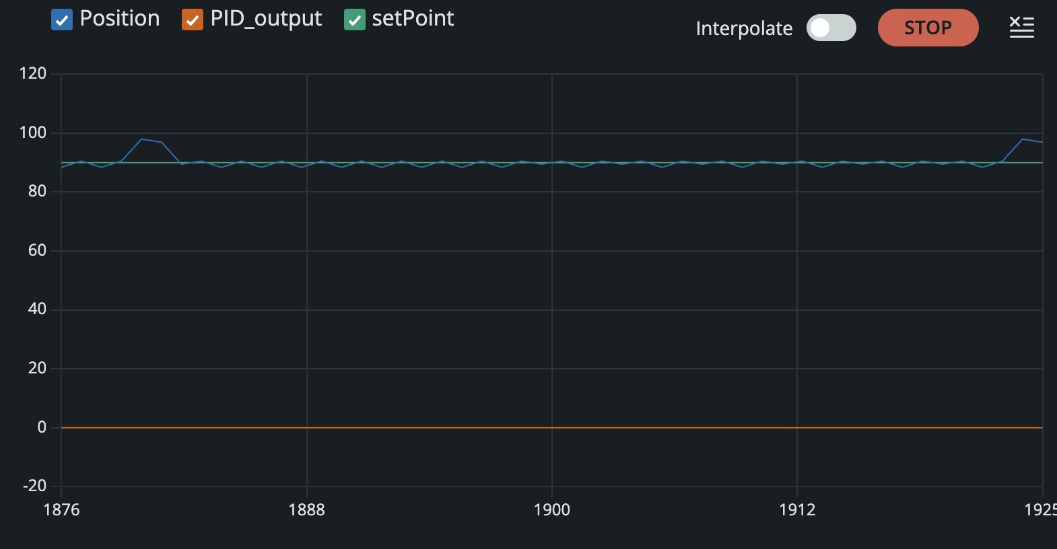

Task 4 – PID controller
Kd=_0.015_
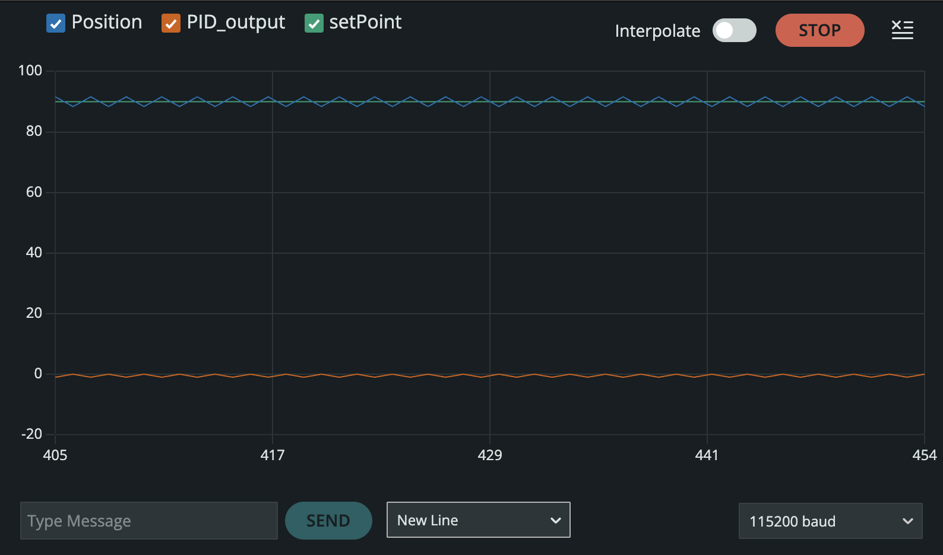

Please Submit the answer sheet to Canvas/Assignments/Lab6_Answer Sheet

